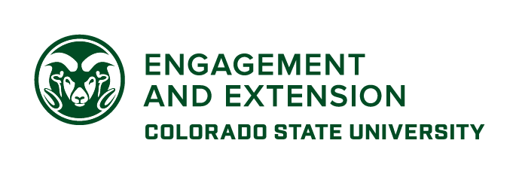
CSU Community Engagement Scholarship Awards Nomination Narrative

All documentation must be typed, double-spaced, in 12-point font (with the exception of Section 6).

Please convert your file to PDF format for submission via the online nomination form no later than February 2, 2026.

Section 1: Abstract
Significance of the Community Engagement Partnership (200-word limit)
Summarize the significance of the community-university partnership and the scholarship embedded in the partnership. Describe how the partnership intentionally studies and/or addresses community issues and concerns, jointly derives solutions, and then publicizes and disseminates what was discovered and/or accomplished.
It should be a concise description that can be used for the Office of Engagement website and related press coverage.
Sections 2-5: Narrative
While word limits are identical, the relative weighting of sections varies in the evaluation of the submission (and differs by award category). Please see the scoring rubric on the final page for more information.
Section 2 - Relationship and Reciprocity between the Community and the University (300-word limit)
Describe the issue, its significance, the relationship between CSU and community, and how reciprocity is a part of the relationship. Who are the key university and community partners? How does an engaged partnership fit into the mission, values, and organizational structure of the university? How did university and community partners work together? What was the role of each partner and what was accomplished? Provide evidence of shared decision-making and partnership empowerment.
Section 3 - Impacts
3.1 On Community Partners (300-word limit)
What were the anticipated benefits for community partners? What has been the impact in the community?
3.2 On University Partners (300-word limit)
What were the anticipated benefits for the University? What has been the impact in the University? How has the university-community partnership impacted the missions of the university and what has changed?
Impacts described in Section 3 must include scholarship and may also include, but are not limited to: student success, workforce and talent development, knowledge generation and sharing, innovation- and technology-based economic development, and social, cultural or community development, as well as additional dollars generated through grants, contributions, fees, etc. How did the partnership promote and sustain economic prosperity within the community by building value in any of the aforementioned areas?
Nominations should include at least one quantitative measure of the described impact and information on how data were obtained. Identify initial funding that supported the development of this engagement initiative and describe how sustainability has been addressed.

Section 4 - Lessons Learned and Best Practices (300-word limit)
What were the challenges for the community and university partners and how were those challenges met? What conclusions and best practices can be drawn from the partnership? These could include but are not limited to: innovative solutions to community issues, the processes of establishing and sustaining a partnership, and changes in the partnership or changes within one of the partners.
Nominations must include information about how these conclusions and best practices have been documented and shared publicly.
Section 5 – Future (300-word limit)
What are the future plans for this partnership? How will the partners continue to work together or how will they determine when the partnership is concluded? Please specify how the award stipend would be used to advance partnership goals and outcomes.
Section 6: Appendix/Supporting Materials (8-page limit, to be submitted as one file)
Please note: This section does not require materials to be double-spaced and in 12-point font.
Applications must include two letters as part of the appendix:
- The first letter must be an endorsement from the dean of the college or head of the major administrative unit of the nominee’s primary appointment.

- The second letter must be from a community partner or consortium of partners. This letter must provide evidence of collaboration, reciprocity, mutual benefit, and the roles of community partners.
Additional supporting materials are welcome within the 8-page limit. Links to websites, videos, blogs, social media outlets, press coverage, etc. may also be provided, as appropriate, however these will be treated as optional reading for interested reviewers.

